Relocation Directory 2016

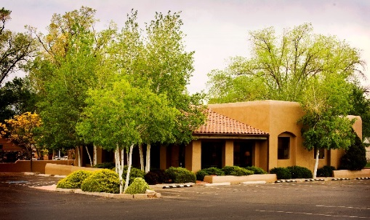
Residents of Prescott are fortunate to enjoy our small town feel while having the amenities of a larger metropolitan area, including comprehensive dental care. Dr. Jason C Campbell, DDS, and his staff have been serving Prescott area residents for the past twelve years. At Jason C Campbell, DDS, Cosmetic & Family Dentistry, Dr. Campbell, Dr. Rick Farnsworth, DDS, and their friendly staff offer services ranging from preventive, restorative, and periodontal care to rehabilitative and reconstruction services, including implants, dentures, and implant retained dentures. Learn more at www.PrescottDentist.com .

With Dr. Campbell’s passion for serving persons who have complex dental needs, and his continuing education from the Ostrow School of Dentistry at USC – School of Prosthodontics, Periodontics & Oral Surgery, he founded the Advanced Prosthetics Institute (API). API treats patients needing complex dental rehabilitation and reconstruction services, including patients with multiple missing teeth, chronic facial pain (Bruxism, TMJD, Migraine Headaches), and those with medical/dental related issues (gastric disorders, autoimmune illnesses, allergies, diabetes, radiation/chemotherapy patients, etc…). API offers surgical prosthetics, including fixed, removable, and complex combination prosthetics. Learn more at www.APIDentalRehab.com

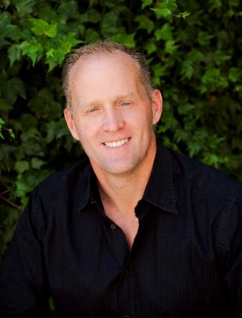 | 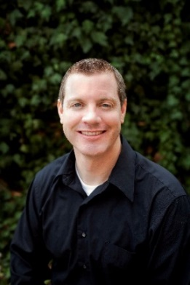
Dr. Jason C Campbell, DDS | Dr. Rick Farnsworth, DDS

Online reviews at www.PrescottDentist.com reflect patient experiences as they enjoy a comfortable and welcoming atmosphere, in addition to, the practice’s focus on educating patients on preventive care – not just treating dental issues. The practice staff is dedicated to educating patients during visits, as well as, through community seminars on various dental related topics.
“We strive to help patients understand preventive care to avoid dental issues, as well as, to better understand their treatment options, if necessary. Our goals are to help patients improve both their oral and overall health.”
Dr. Jason Campbell, DDS

Services provided at the office of Jason C Campbell, DDS, Cosmetic & Family Dentistry and the Advanced Prosthetic Institute include:

General Preventive & Restorative Dentistry
Periodontal (Gum Disease) Treatment
Comprehensive Rehabilitation & Reconstruction Services:
Implants Implant Retained Dentures
Same Day Crowns & Bridges Full and Partial Dentures
Complex Reconstruction Cases Sedation Dentistry
TMJD & Migraine Headache Treatment
Smile Makeovers
ZOOM! Professional Whitening

To provide improved patient comfort and optimal outcomes, the staff uses the following state-of-the-art technologies:

- Digital X-rays
- Intraoral camera
- 3D CT Imaging
- Laser Scanning
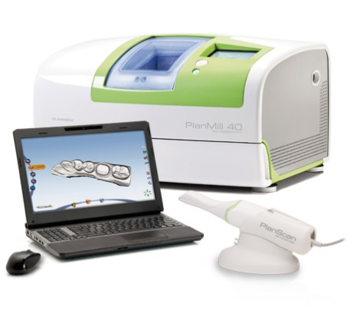

- Digital scanning and mill for Same Day Crowns & Bridges
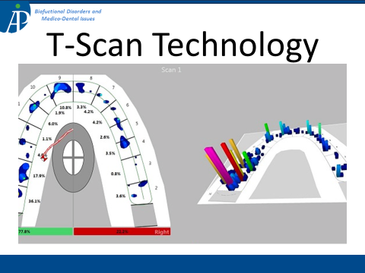

- T-Scan© Digital Bite Dynamics Analysis
Call 928.776.1208 to schedule your appointment. Mention ad to receive your FREE New Patient Exam and X-rays. Emergency appointments and financing options available.

JASON C CAMPBELL, DDS, COSMETIC & FAMILY DENTISTRY WWW.PRESCOTTDENTIST.COM
ADVANCED PROSTHETICS INSTITUTE WWW.APIDENTALREHAB.COM
139 W. Whipple St. Prescott, AZ 86301 | 928.776.1208

